**WORKING WITH VPNS**

* **AFTER CONNECTION**

1. CONNECTED

* .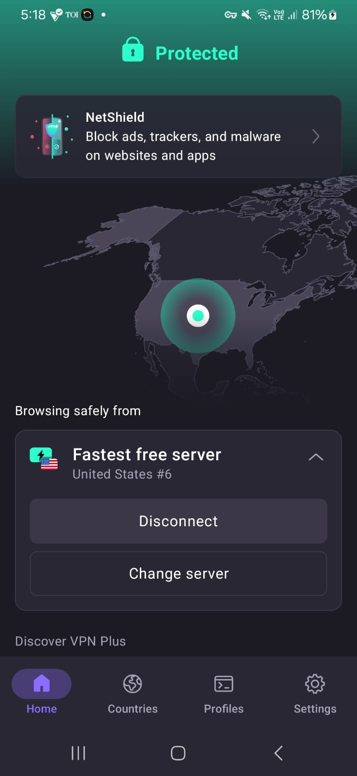

2) IP ADDRESS VERIFYING

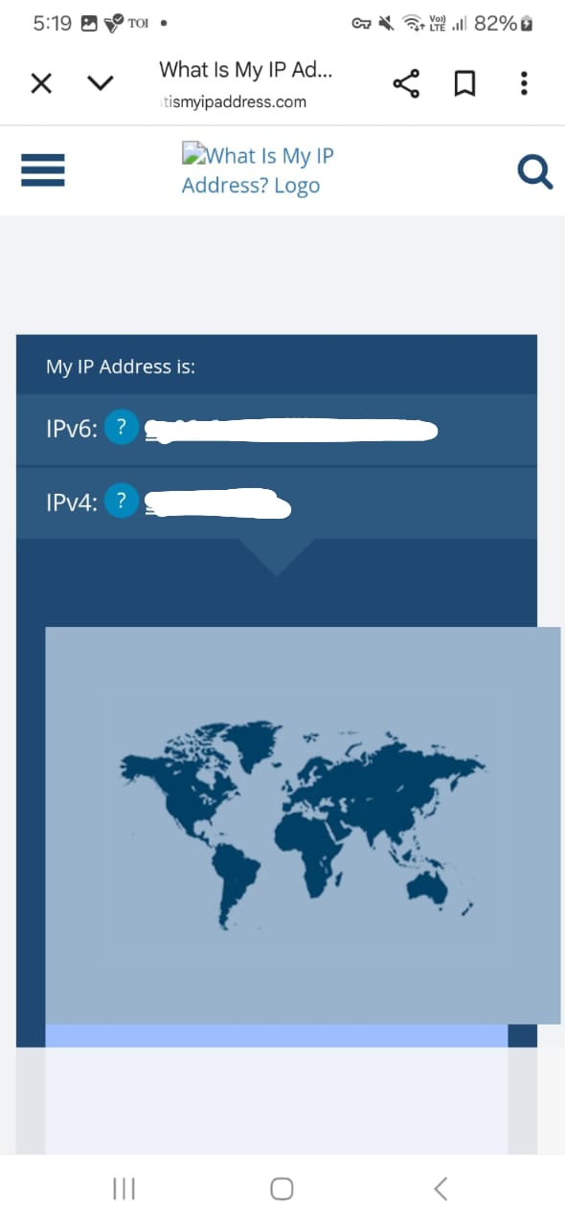

3) SPEED TESTING

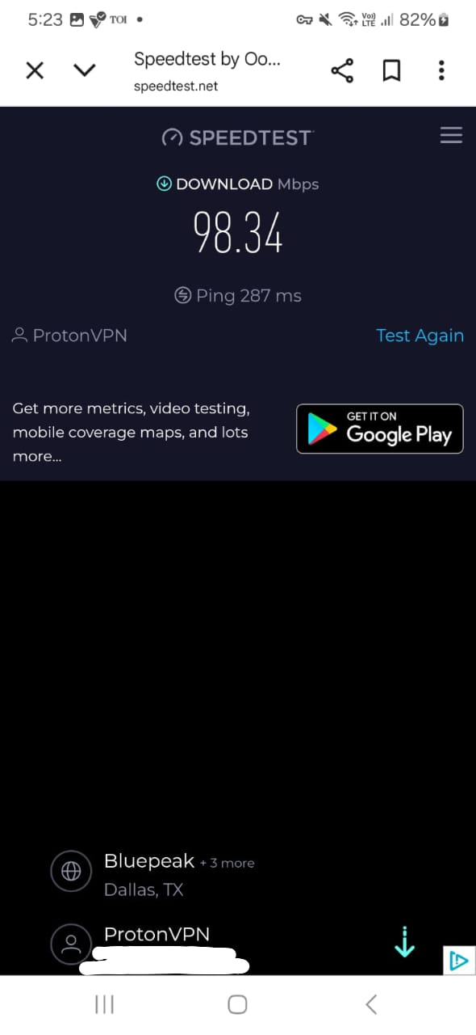

* DISCONNECTED THE CONNECTION

1. IP ADDRESS

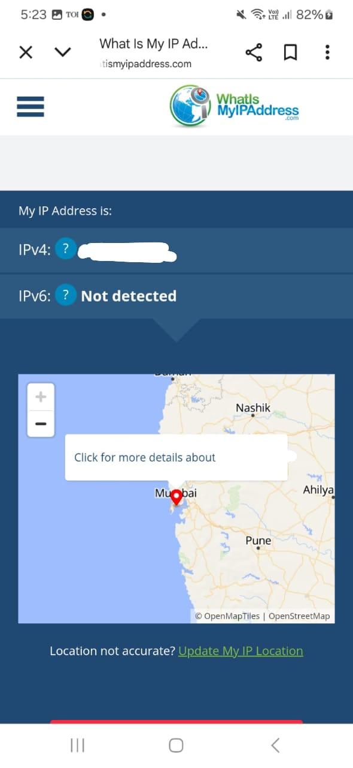

3) SPEED TESTING

